**Big Mountain Resort: Summary of the data driven analysis for the average Ticket Price**

**Part 1: Average Ticket Price**

* The average ticket price for the Big Mountain Ski resort was modelled using a Randon Forest regressor using the ski data from 276 resorts across the US out of a total of 329 present in the data before pre-conditioning.
* The modelled price was **$95.87** which was roughly 18% higher than the current price of $81.
* This result shows that Big Mountain resort has been charging significantly less compared to the market considering the facilities it provides for its visitors.
* The mean absolute error for the predicted ticket price was $10.39. Management should definitely consider increasing the ticket price to at least $86 (by 6.17%) which, while keeping the total cost within error limits, will bring an additional revenue of $8.75 M assuming there will be 350k visitors in a season and each visitor would buy a 5-day ticket. The proposed increase would also cover the costs of installation pf the new chair.

**Part 2: Comparison of facilities in Big Mountain compared to the market**

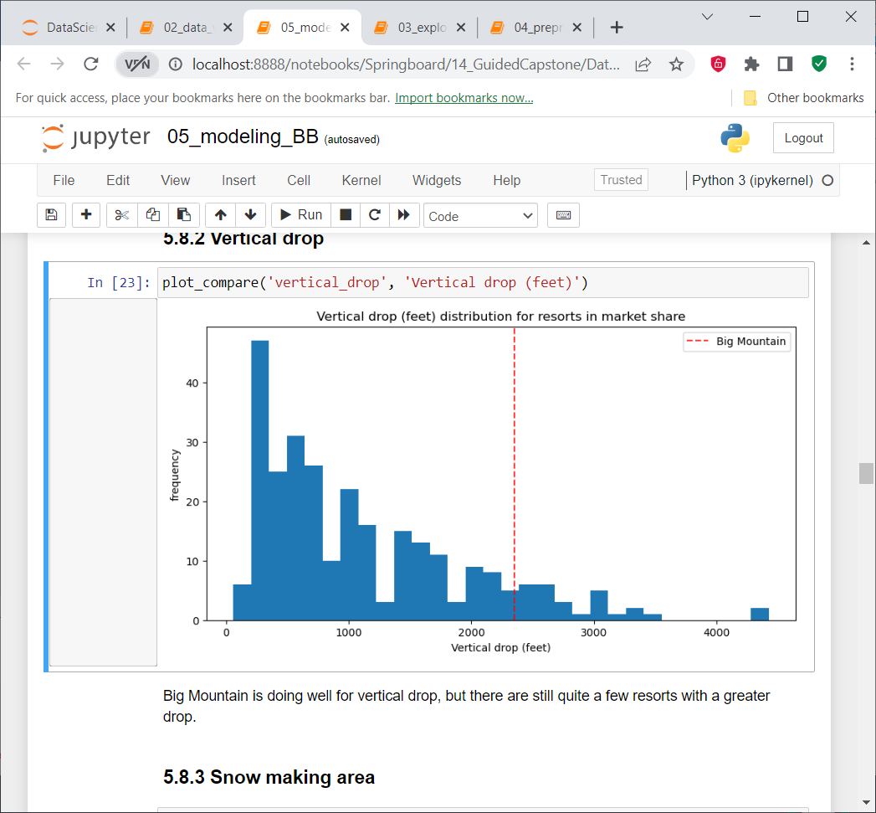 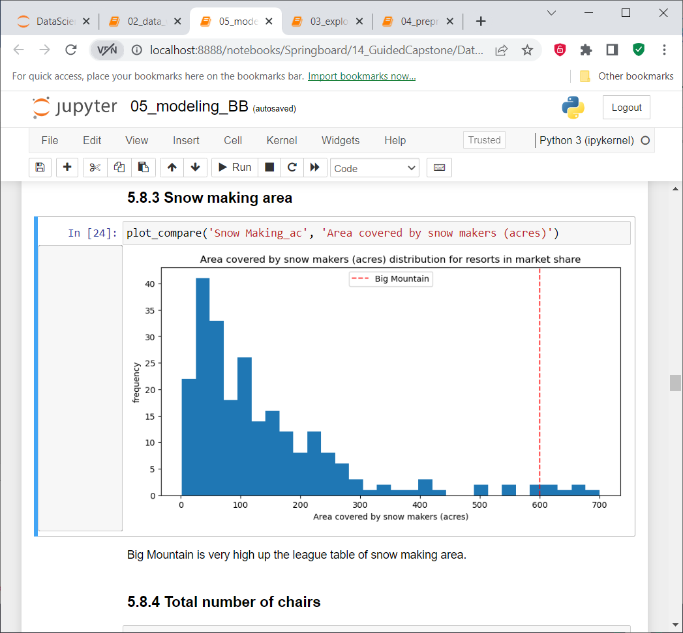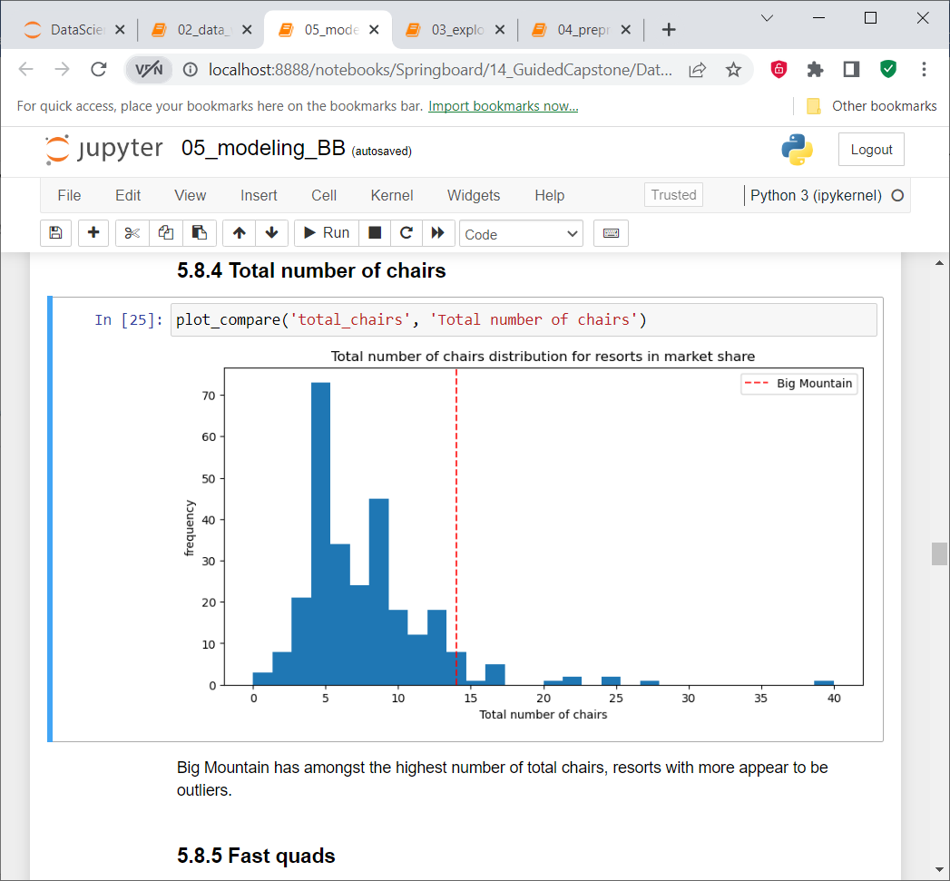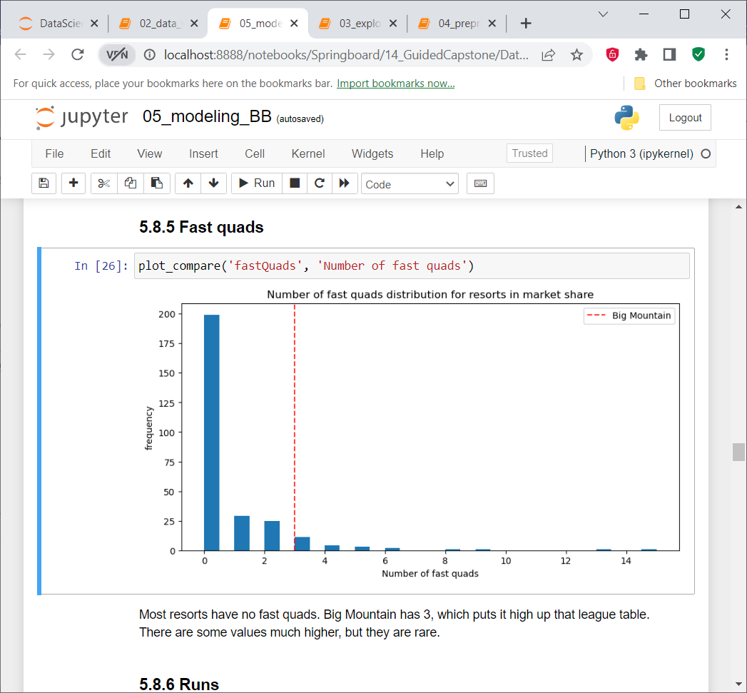

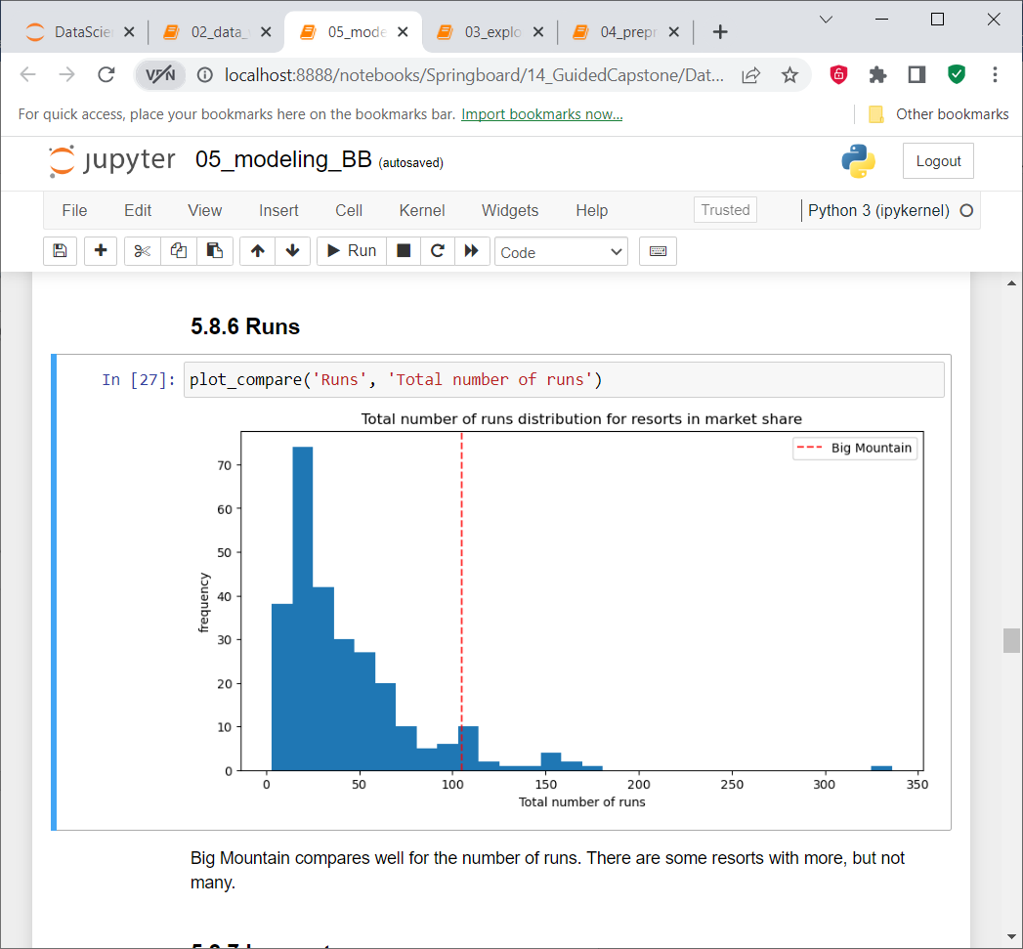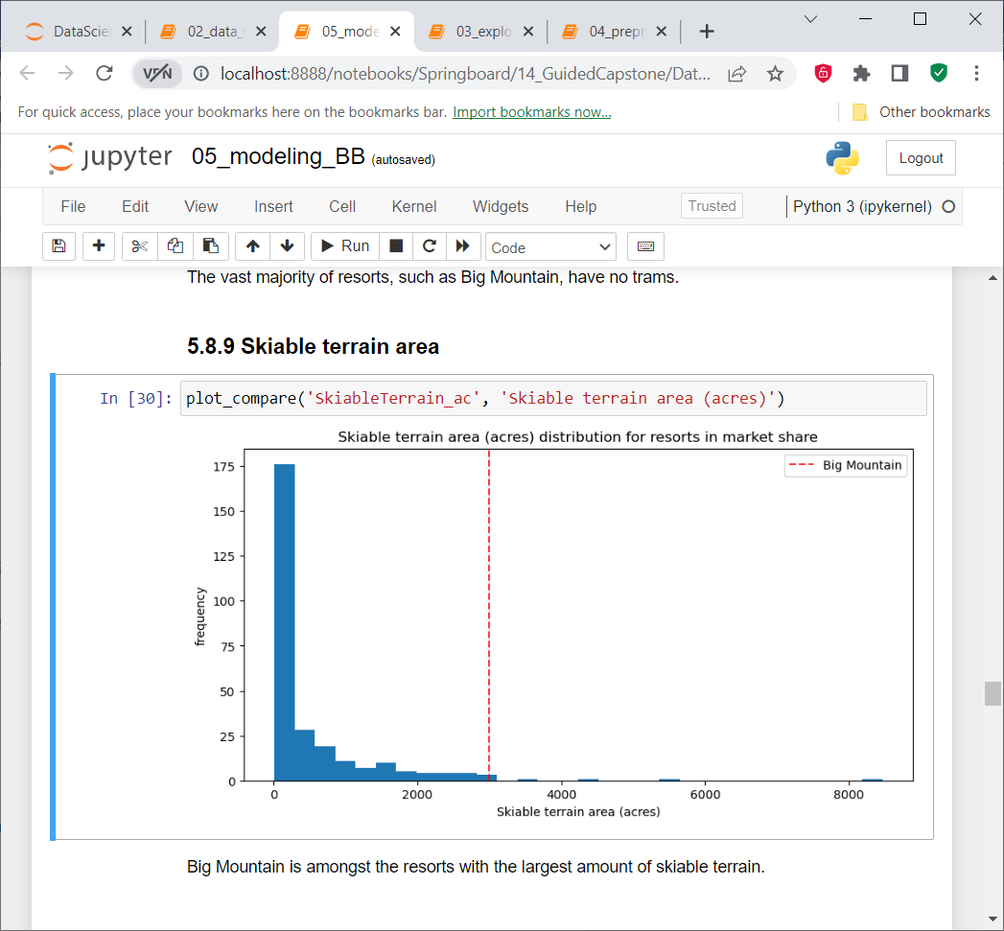

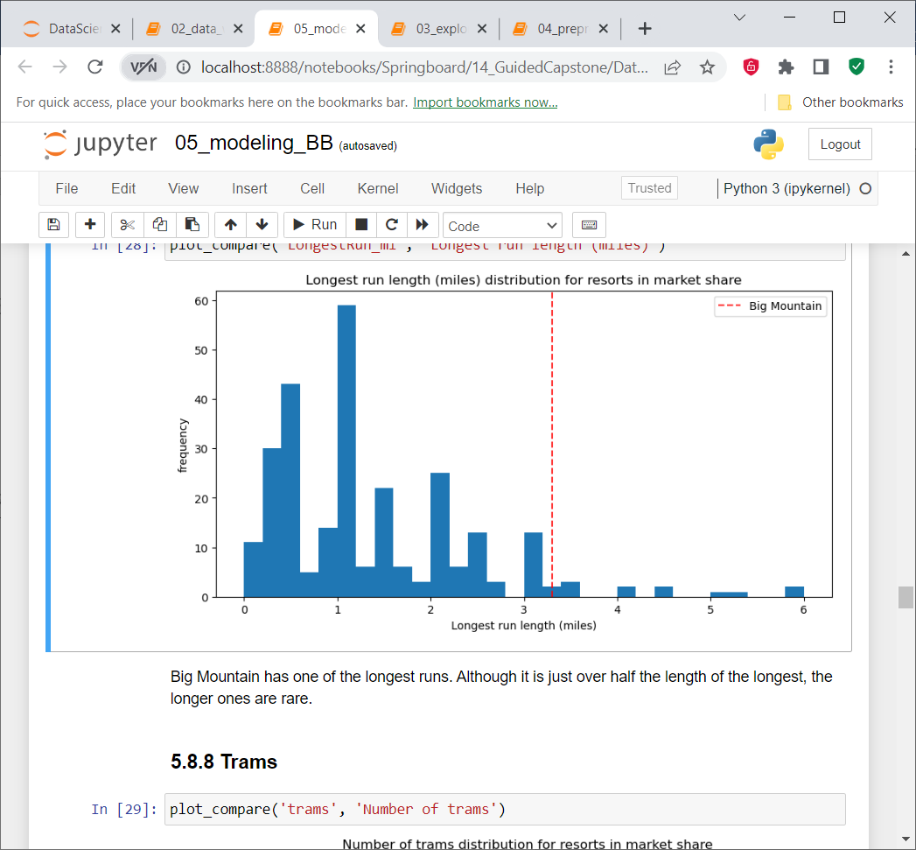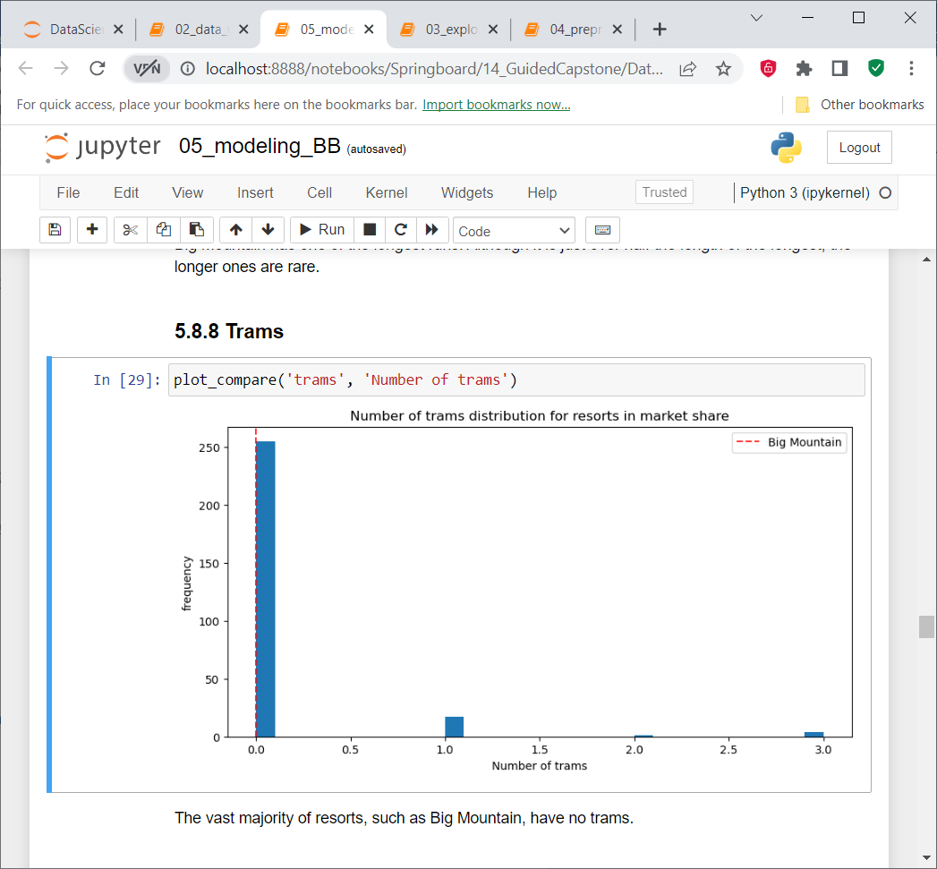

* Facilities at Big Mountain are generally at the higher end compared to the market. Specifically for two of the factors ‘ Skiable Terrain Area’ and ‘Snow making area’ Bog Mountain is among the best in the country. One feature that Big Mountain can improve on is the ‘Vertical drop’. Since this feature has a strong correlation with ticket price the management can consider increasing this to make the resort more attractive.

**Part 3: Future improvements**

* Adding another run, increasing the vertical drop by 150 ft and installing an additional chair lift can support a price crease of USD 2 amounting to 3.5M addiotnal revenue that should be profitable including the installation and operational costs.
* Closing 5 of the least used runs has a very small impact on ticket price (less than 75 cents) while reducing the operational costs for those runs.

Finally, this data analysis can be improved by adding the operational costs for each facility. One of the drawbacks of this study is that installation and operating costs of each type of facility is not taken into account. In future if we would like to add certain facilities that can bring more visitors but keep the costs low then the current data analysis may not be adequate.